FakeNewsDetector
AI-Powered Desktop App to Detect Fake News in Real Time
Java • JavaFX • Python • Flask • Scikit-learn • NLP

Suggested LinkedIn Post Title
"FakeNewsDetector – An AI-Powered Desktop App That Tells Real News from Fake in Seconds"

Short Description (for LinkedIn caption)
I built FakeNewsDetector, a desktop application that uses Natural Language Processing and Machine Learning to analyze news content and instantly flag whether it is likely Real or Fake, complete with a confidence score. The app combines a clean JavaFX desktop interface with a Python/Flask AI backend, showcasing a full end-to-end integration between a Java front end and a Python machine learning model.

Project Overview
FakeNewsDetector is a full-stack desktop application designed to combat misinformation by analyzing the text of a news article and predicting whether it is authentic or fabricated. The project pairs a JavaFX graphical interface with a Python-based machine learning microservice, demonstrating practical experience in cross-language application architecture, REST API communication, and applied NLP.
Users can either type or paste an article directly into the app, or upload a .txt file containing the news content. The application sends this text to a local Flask API, which cleans and vectorizes the text and runs it through a trained classification model. The result, a Real/Fake label with a confidence percentage, is then displayed back in the desktop UI with a color-coded confidence bar (green for real, red for fake).

Key Features
- Clean, modern JavaFX desktop interface with a custom animated splash screen
- Paste text directly or upload a .txt news file for analysis
- Real-time AI prediction with a Fake/Real verdict and confidence percentage
- Color-coded confidence meter that shifts from red to green based on prediction confidence
- Python/Flask REST API backend serving the trained ML model
- NLP preprocessing pipeline: text cleaning, stopword removal, and stemming (NLTK)
- TF-IDF vectorization paired with a Multinomial Naive Bayes classifier (Scikit-learn)
- Trained and evaluated on a large labelled dataset of real and fake news articles

Tech Stack
- Frontend: Java, JavaFX, FXML, CSS
- Backend / AI Service: Python, Flask, REST API
- Machine Learning / NLP: Scikit-learn, NLTK, TF-IDF, Multinomial Naive Bayes
- Build Tool: Maven
- Architecture: Desktop client communicating with a local AI microservice over HTTP/JSON

How It Works
- 1. The user enters or uploads news text in the JavaFX interface.
- 2. On clicking “Check News,” the app sends the text as JSON to the Flask API (http://localhost:5000/predict).
- 3. The Flask backend cleans the text (removes punctuation/numbers, lowercases, removes stopwords, applies stemming).
- 4. The cleaned text is transformed using a pre-trained TF-IDF vectorizer.
- 5. A trained Naive Bayes model predicts the class (Real or Fake) and returns a confidence score.
- 6. The JavaFX app displays the verdict, confidence percentage, and a color-coded progress bar.

What I Learned
Building FakeNewsDetector strengthened my understanding of integrating a Java desktop client with a Python machine learning service over a REST API, structuring an end-to-end NLP pipeline from raw text to a deployed prediction, and designing a clean, user-friendly desktop UI with JavaFX and CSS styling.
Application Screenshots:
Below are screenshots of the application in action.

1. Splash Screen

Animated splash screen shown while the application loads.

2. Main Window – Initial State

The main interface: enter or upload news text, then click “Check News.”

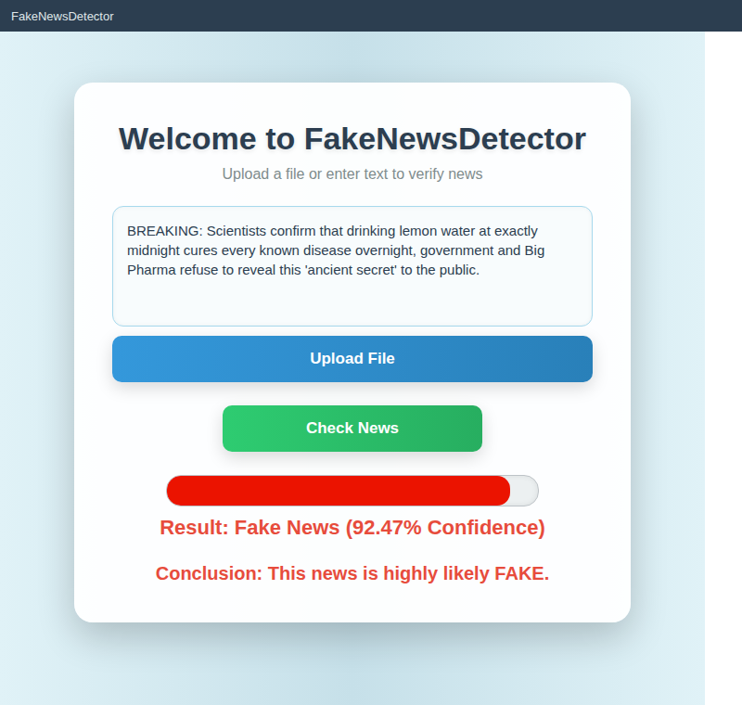
3. Result – Fake News Detected

Example: a sensational, fabricated claim is flagged as Fake News with 92.47% confidence.

4. Result – Real News Detected

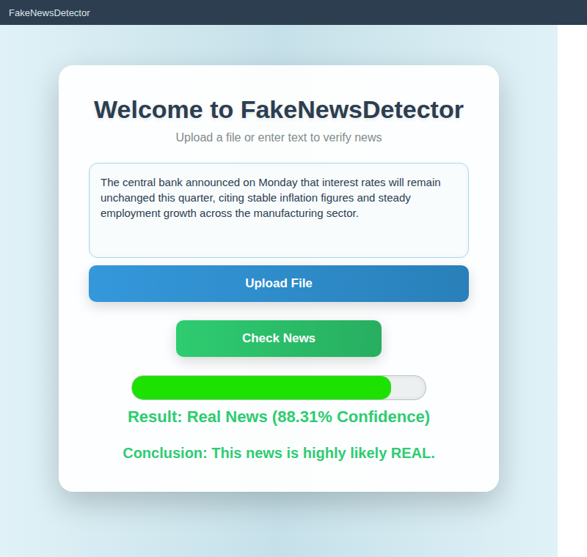
Example: a factual news snippet is classified as Real News with 88.31% confidence.

